Zonta Club of Oneida Area
News and Views
Volume 34, No. 6
June, 2020
Area 2 District 2,
Chartered June 1, 1924

PRESIDENT’S PEN

Greetings to all my fellow Zontians,

I hope this newsletter finds that we are all well, wearing masks and practicing social distancing. Soon the county will be moving towards Phase 3 on the recovery schedule, and by fall we will be able to resume meeting at Theodore’s and still be in compliance with plated meals. What a wonderful thing THAT will be!

Mayor Helen Acker has given the go ahead for garage sales in Oneida, so in view of that the board has decided to hold a sale this summer. The tentative dates are July 17th and 18th at Barb Allen’s home.

Resignations were accepted with regret from Laura Duchene, Pam Kines and Joanne O’Connell. Many thanks, ladies, for your years of service to Zonta!

Please add these dates to your calendars: July 15th planning meeting at Cindy’s, and August 19th our picnic at the Town of Vernon pavilion. We will induct our new members at the picnic.

We have a committee change in that Fay Eastwood will be the new chair and liaison for LAA/IR/UN.

This June 17th meeting will, with any luck, be our last Zoom meeting. I hope to see you all then on my computer. Better communication through technology!

Cindy

CLUB NEWS

- KIVA update – Our club has made a new loan to Abra Makoboe in Togo, a divorced woman who sells juices in hopes of getting out of poverty and attaining financial freedom.

- Our garage sale is scheduled for July 17th &18th at Barb Allen’s house 369 Cleveland Ave, Oneida. Keep saving those garage sale goodies.

- We're still unsure about AMBA and the circus, a lot will depend on the situation with the school at the time of the event.

- We have received a resignation from Pam Kines, who will be spending half of her time now in Florida.

- We need to assemble more chemo care bags since our supply has run out. Cindy will contact Pam for the necessary information.

- There will be a planning meeting on Wednesday, July 15th at 5:30pm at Cindy's house.

- Our annual picnic will be held August 19th, at 5pm in the Town of Vernon pavilion. No word
on the catering at this time.

>>> JUNE BIRTHDAY <<<

Barbara Rowlands – June 8th

UPCOMING EVENTS

Wednesday, June 17th - Business meeting via Zoom, 7pm

Wednesday, July 15th - Programming meeting at Cindy Thurston’s home, 5:30pm

Friday July 17th & Saturday July 18th - Garage sale at Barb Allen’s house, 369 Cleveland Ave, Oneida.

August TBA – Annual picnic at Town of Vernon pavilion, 5pm

COMMITTEE REPORTS

Awards & Finance: (Co-chairs: Sue Pulverenti & Maria Schmitt). A winner has been chosen for the Mildred Ridley Award.
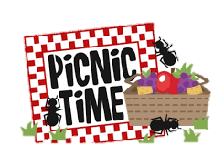
Advocacy & Legislative Awareness: (Chair: Fay Eastwood) Our club needs to figure out how to use the $100 we received from District for domestic violence efforts. Madison County has been suggested.

Membership & Reservations/Fellowship: (Chair: Sharon Taylor & Nancy Ginter). No report

Newsletter & Public Relations/Communications: (Co-Chairs: Jan DeLuke & Sandy Finley & Fay Eastwood) Please submit your information for the newsletter to Jan by the MONDAY following the monthly board meeting. Thanks.

Nominating: (Diane Belusar & Nancy Ginter) Their work is done – for now!

Status of Women Achievement: (Chair: Carol Bandlow) No report.

Fay’s Forum – Life is a cup ️

For this month’s Forum, I’m simply sharing a sentiment I recently found which I thought was appropriate for the problems now facing us all.

You are holding a cup of coffee when someone comes along and bumps into you or shakes your arm, making you spill your coffee everywhere. Why did you spill the coffee?
‘Because someone bumped into me!’ Wrong answer.
You spilled the coffee because there was coffee in your cup.
Had there been tea in the cup, you would have spilled tea.
Whatever is inside the cup is what will spill out.
Therefore, when life comes along and shakes you (which WILL happen),
whatever is inside you will come out. It's easy to fake it, until you get rattled.
So, we have to ask ourselves, ‘What's in my cup?’
When life gets tough, what spills over?
Joy, gratefulness, peace and humility?
Anger, bitterness, harsh words and reactions?
Life provides the cup, YOU choose how to fill it.

Today let's work toward filling our cups with gratitude, forgiveness, joy, words of affirmation and kindness, gentleness and love for others.
(Shared from a friend whose cup is full of goodness and inspiration.)

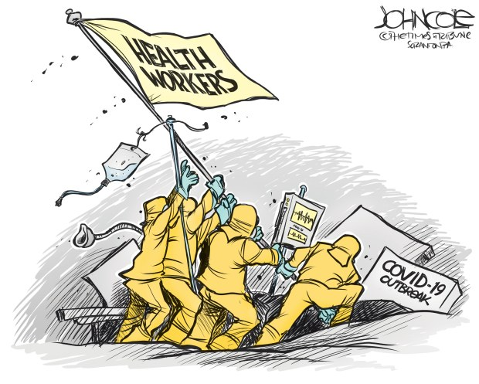

That thousands of years ago, the Ancient Romans named the month after the goddess Juno, who was the patron of marriage and also responsible for looking after the wellbeing of women? (Could that be because June is a beautiful month?)

That June’s full moon - typically the last full moon of spring or the first of summer - is traditionally called the Strawberry Moon? The name originated with Algonquin tribes in eastern North America who knew it as a signal to gather the ripening fruit of wild strawberries.

It is the month of June,
The month of leaves and roses,
When pleasant sights salute the eyes,
And pleasant scents the noses.
N. P. Willis (1807-67)

ZONTA CLUB OF
ONEIDA AREA
CURRENT INFO

Zonta International
President: Susanne von Bassewitz
Vice President: Ute Scholz
Website: zonta.org

Zonta District 2
Governor: Irene Orton
Lt. Governor: Theresa Harris
Area 2 Director: Christine Alexander
Website: zontadistrict2.org

Zonta Club of Oneida Area
2020 -2022 Officers
President: Cindy Thurston
Vice President: Karen Puglisi
Recording Secretary: - Sharon Taylor
Corresponding Secretary: Diane Belusar
Treasurer: Maria Schmidt
Assistant Treasurer: Gail Strong
Historian: Sandy Finley

Board of Directors
Annette Maguire – 2020-2021
Fay Eastwood – 2020-2021
Barbara Johnson – 2020-2022
Pat Pritcher – 2020-2022

Nominating Committee
Sandy Finley
Sue Pulverenti
Virginia Seminaroti

Website: oneidazonta.org
Mailing address: P.O. Box 199, Wampsville, NY 13163
Email address: Oneida@zontadistrict2.org

